**CICD Pipeline Project**

**Continuous integration**

1. Create a project in Jenkins, each project will be a job
2. Create a job to checkout the code and build the project
3. If it will be a docker project then build the docker image

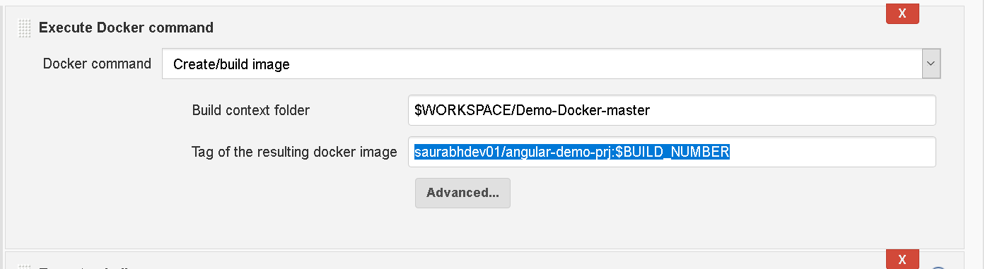

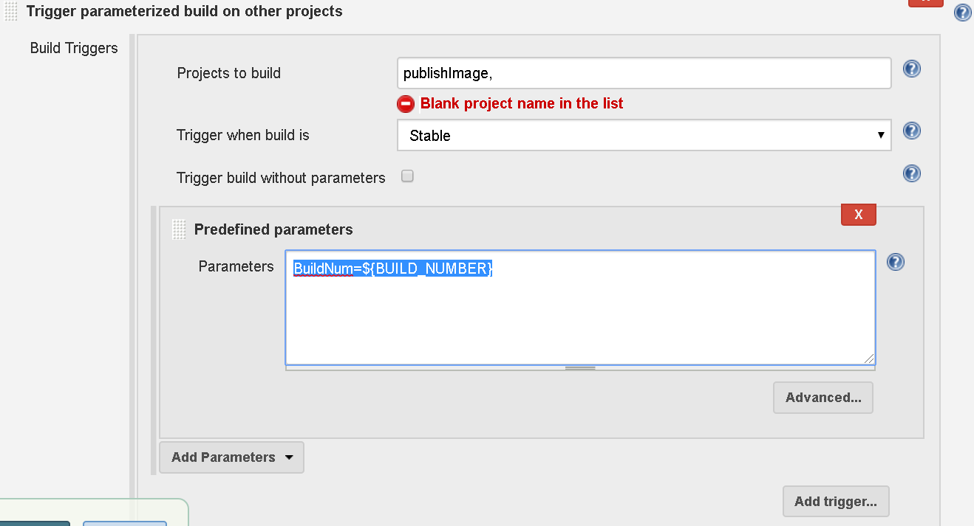

1. Create another job to push the artifacts/docker image to docker hub

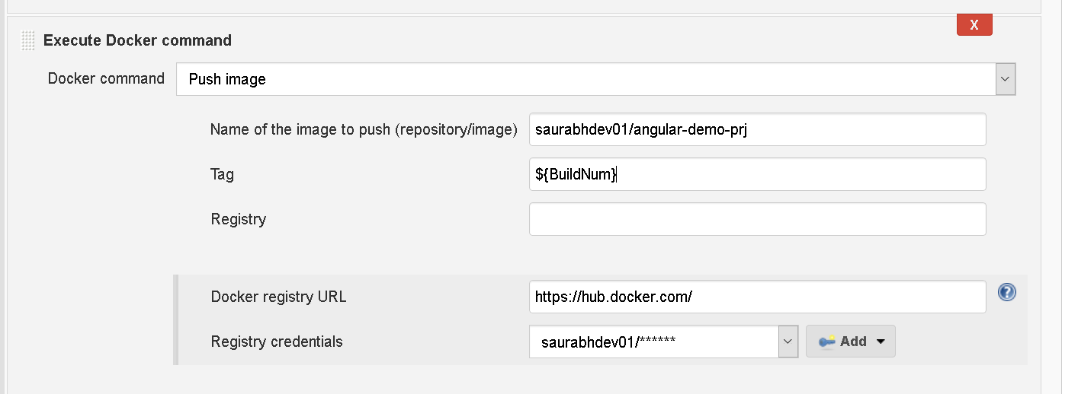

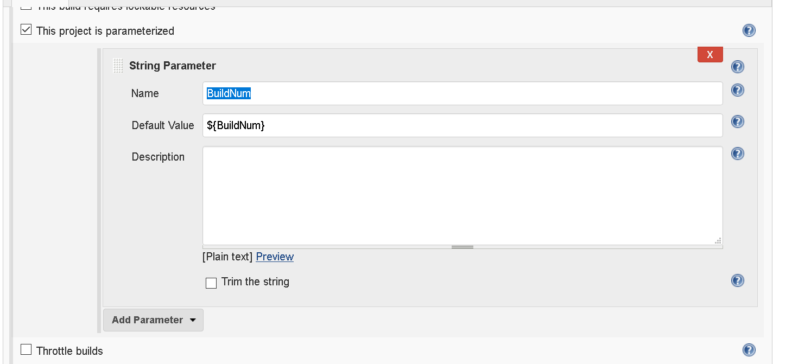

1. Once the jobs will be created then integrate them as downstream and upstream jobs

**Continuous Deployment**

1. Create a project/job for the continuous deployment
2. Create a job to pull the image from dockerhub

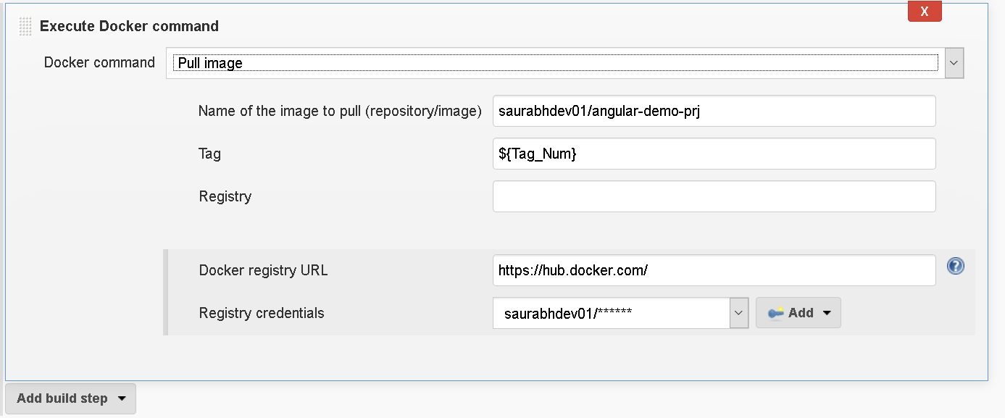

1. Create a job to do the deployment

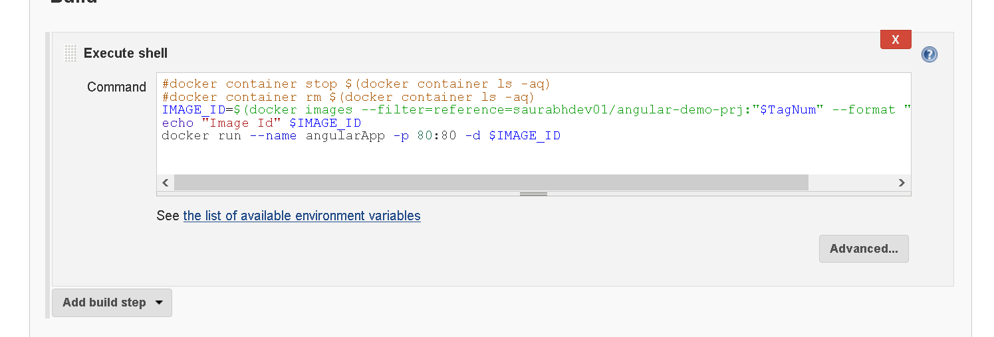

**Jenkins configuration**

1. Goto Jenkins
2. Goto Manage Jenkins -> Configure system
3. Search for docker and make changes in *Pipeline Model Definition*

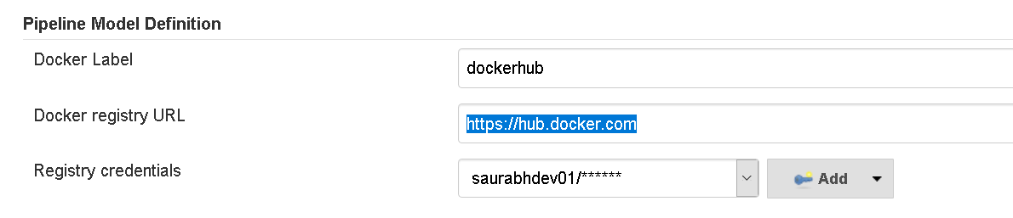

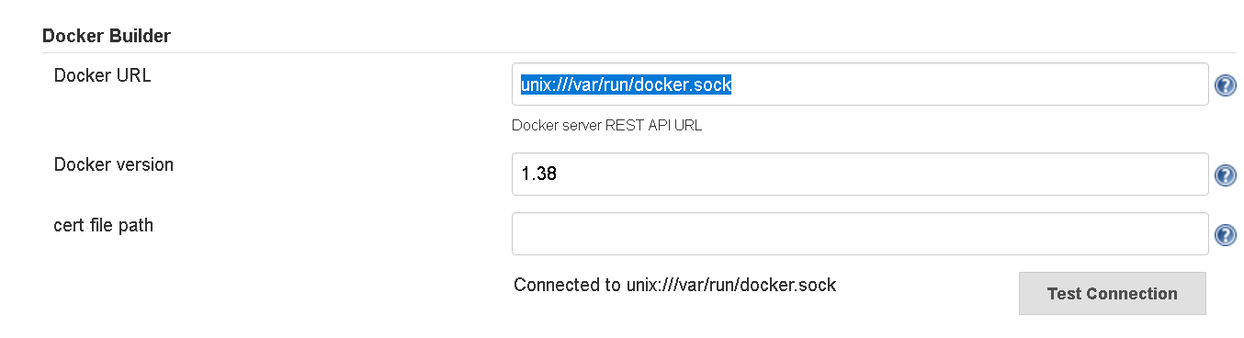

CI/CD pipeline View

